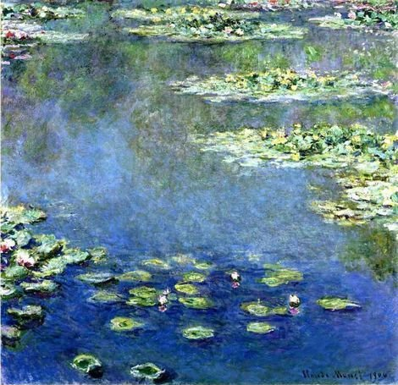

living deeply

A Mindfulness Retreat in the tradition of
Thich Nhat Hanh with Dharma Teacher Chan Huy

Thursday March 3rd – Sunday March 6th

“The Present Moment contains past and future. The secret of transformation is in the way we handle this very moment.”
Zen Master Thich Nhat Hahn

Retreat begins at 7PM Thurs and ends 2PM Sunday.
Held at Kearns Spirituality Center, Allison Park, PA.

Cost for the retreat is $250 for 4 days ($190 for 3 days).
-Vegetarian meals and overnight accommodations included.
Register by February 17th; cancellations after February 25th will receive a partial refund of $100. Limited scholarships are available.

For more information or to register, please contact:
- Bill Meoni 412-570-0082 billmeoni@hotmail.com
- Michael Sutherland 412-363-5885 titanium507@gmail.com

www.laughingrivers.org

